# **Caremark.com – Update Order Shipping Address Website**

|  |
| --- |
| **Scenario/Member Statements** |

I've recently moved. Where can I change my address?

I live in Maine for six months and Florida for six months. Can I have two delivery addresses?

I’m going to be staying at my friend’s house for a few months, is there a way for me to temporarily change my address?

|  |
| --- |
| **Process Demonstration – Video Walkthrough** |

Click [Shipping Address and Alternate Address Video Demonstration](https://thesource.cvshealth.com/nuxeo/thesource/#!/view?docid=be567046-1b05-40c8-a33c-a9e6ab23cc55) to view a video walkthrough of overall steps outlined in this job aid.

|  |
| --- |
| **Change Shipping Information** |

1. Click **Profile** in the upper right.

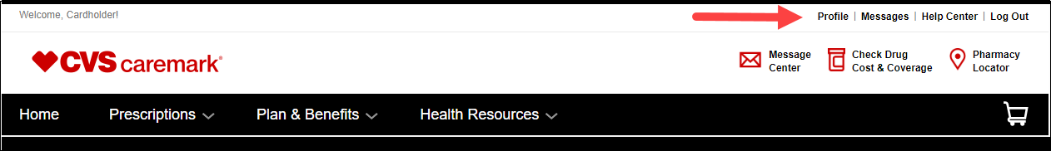

1. Click **Shipping information** on the left.

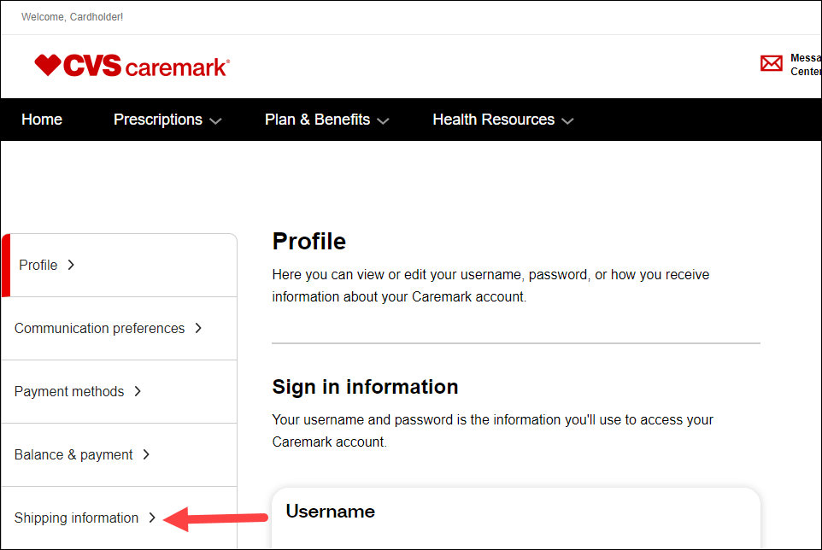

1. Review the Primary address.

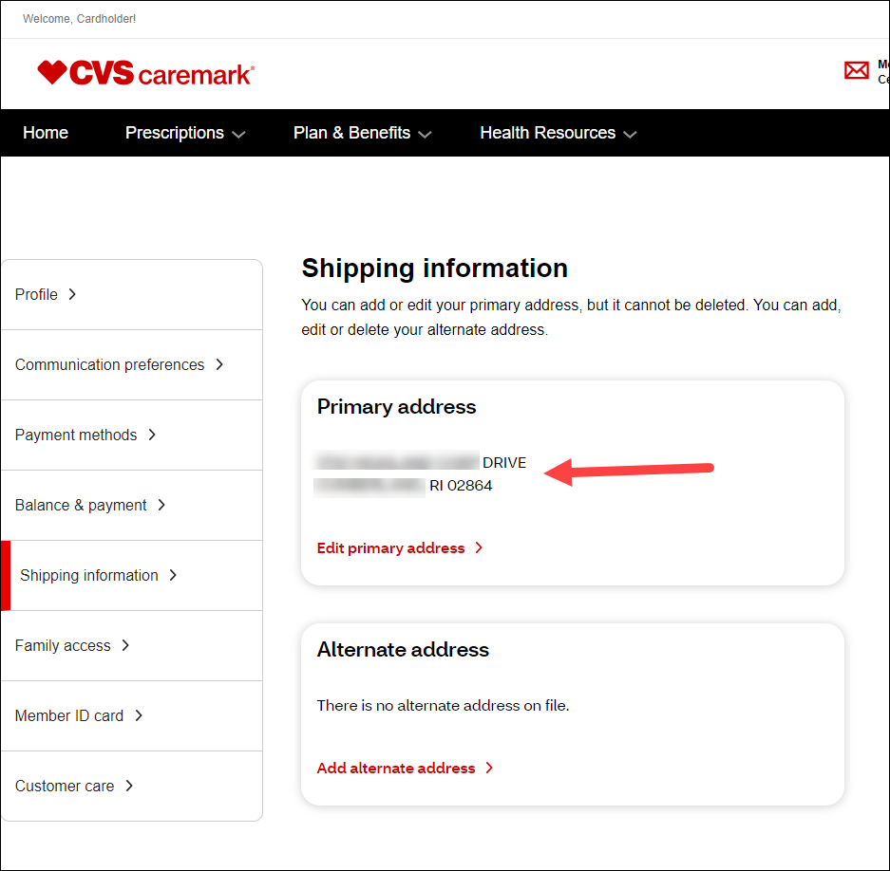

1. Click Edit primary address.  Address changes will **NOT apply or be used for orders currently in process**.

* Members can change the address on orders in process (prior to Label Print) or Pending Auto Refill and Auto Renewal orders from the Order Status page. Refer to [Caremark.com – Mail Order Request (Refill)](https://thesource.cvshealth.com/nuxeo/thesource/#!/view?docid=50e0a62b-df96-401e-9ab5-c52fa3774a17).

|  |
| --- |
| **Add or Review Existing Alternate Shipping Address** |

The **Alternate Shipping Address** requires an effective date and an expiration date. If any alternate address is entered with effective/expiration dates, **any order placed by any method during the alternate dates** will ship to the alternate address.

1. Fill out the alternate address information.

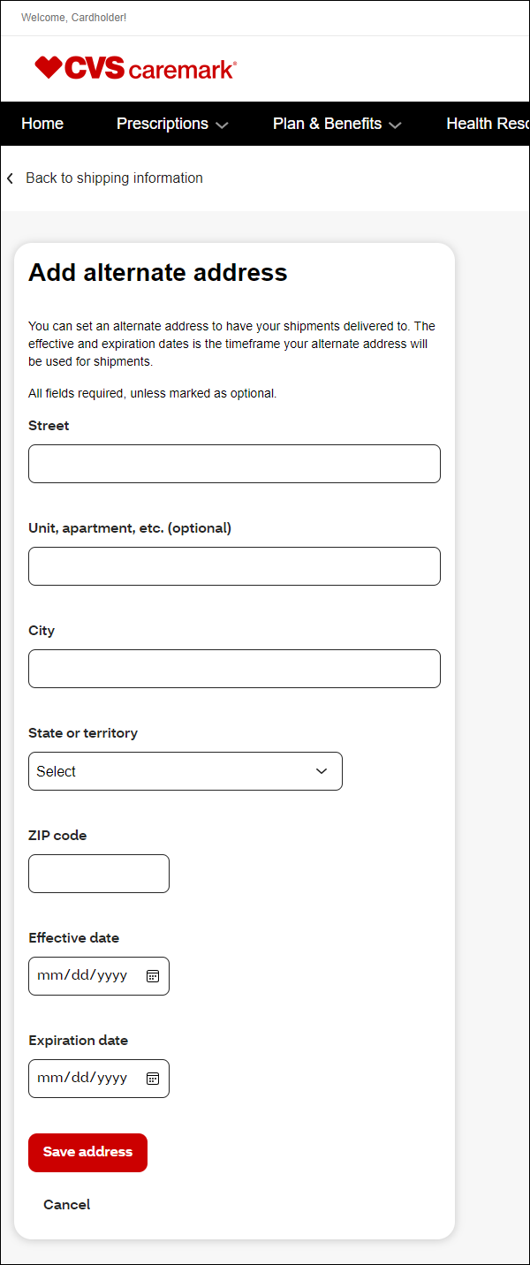

1. Click **Save address**.

|  |
| --- |
| **Shipping Address Key Points** |

Online changes will automatically update Compass.

**New Auto Refill/Renewals (Orders currently in the mandated 16-day hold):** The order will be shipped to the address on file where the order was initiated.

**Existing Auto Refill/Renewals (Outside the 16-day hold):** The order will ship to the **current** address on file for the member, unless the member calls Customer Care.

|  |
| --- |
| **Related Documents** |

[Caremark.com - Common Member Assistance Call Types Index](https://thesource.cvshealth.com/nuxeo/thesource/#!/view?docid=947b0b38-401d-4b18-a08e-60348558a9b9)

**Full Details Document:**  [Caremark.com – Member/Accessing and Updating My Profile](https://thesource.cvshealth.com/nuxeo/thesource/#!/view?docid=80d873ee-5a3b-4ca5-ac45-2c8027c56643)

Not To Be Reproduced Or Disclosed to Others Without Prior Written Approval

**ELECTRONIC DATA = OFFICIAL VERSION / PAPER COPY = INFORMATIONAL ONLY**